**AN 0001**

**ECE 09.402 Section 3**

**F23 Electronics II**

**Safety Equipment – Gas Sensor Badge & Watch**

Zachary Bravo

Dec 2023

**Overview**

The system designed in this Application Note (AN) is a prototype wearable IoT system that provides safety information through a One-Way Communication scheme. The focus of the application is employee safety, and business liability. As this is a wearables device, the power system of the wearable is an important component that is described. This system is aimed to be implemented in a hazardous work environment where dangerous gases can be found in the area.

**Keywords**

Wearable Electronics

ESP32

IoT Device

Power System

**Introduction**

The Gas Sensor & Badge combination is a wearable device that has a wearable badge that senses the air quality in the area and transmits that information to a watch device. When the air quality is found to be too dangerous a buzzer is signaled to audibly get the user’s attention. Along with those functions, the badge and the watch contain battery measurement functions to alert the user when they should prepare to recharge. The air quality and battery level are sent to a visual monitor that displays all three values. This prototype system makes usage of the ESP-WROOM-32 microcontroller for Wi-Fi one-way connections. Due to the regulator included on the board, the battery is modular and dependent on usage case. This AN serves as being the first of many revisions. Planned future work is included in this AN.

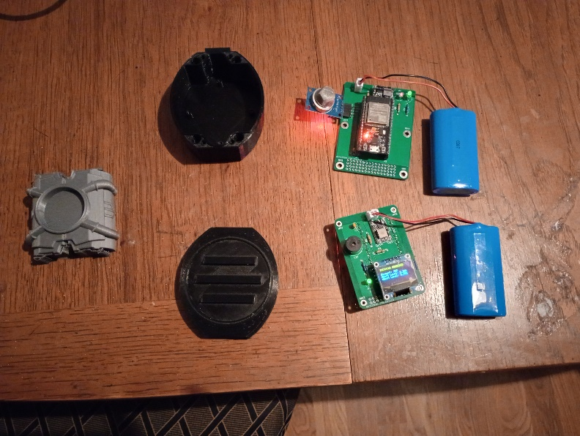

**Fig. 1.** Top-Down View of Badge & Sensor

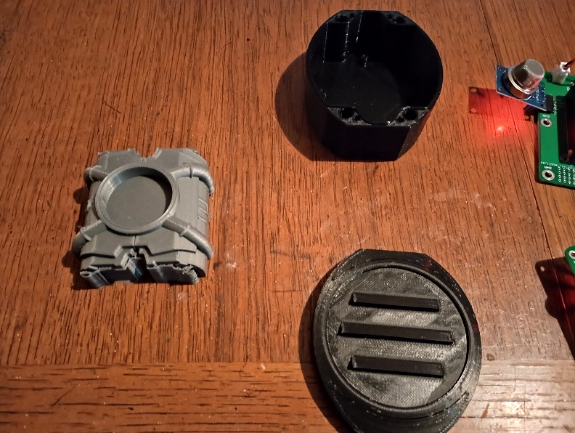

**Fig. 2.** Close Up of Enclosures

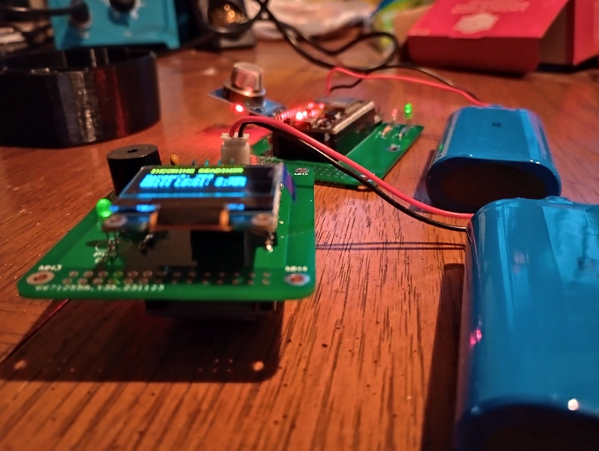

**Fig. 3.** Edge Look at Electronics

**Appendix**

Block Diagram

Schematics

PCB Layout

3D Models

Coding

Revisions

Future Work

Discussion & Conclusion

Bill Of Materials

References

**Schematics**

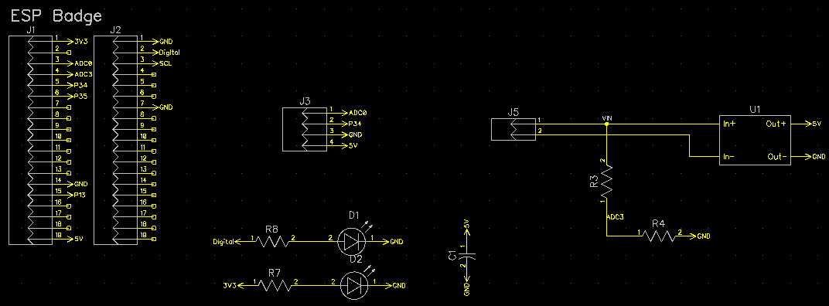

**Fig. 4.** Schematic of the Badge

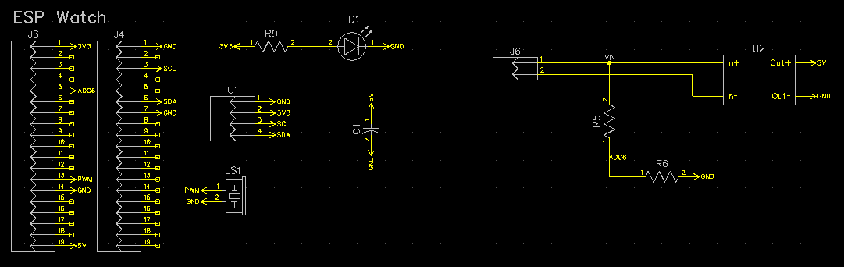

**Fig. 5.** Schematic of the Watch

The Schematics for both boards pretty similar to each other. This is because they both include similar functions such as . They also share the same microcontroller, the ESP-WROOM-32 or ESP-32S. For both schematics, there were headers for the microcontroller, and a voltage regulator with voltage reading from a voltage divider is included. The differences include the lack of LEDs for the Watch. As the Watch includes a Buzzer, the extra signal LED is not needed. There is also a bulk capacitor for the display. The display is not a part of the Badge, but the Watch needs it to function as a watch and is done through headers in this revision.

**PCB Layout**

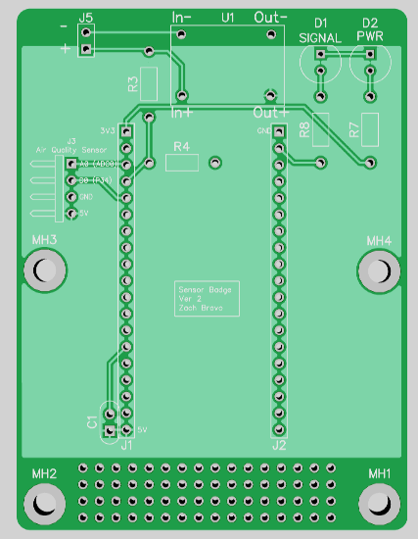

**Fig. 6.** PCB Layout of the Watch

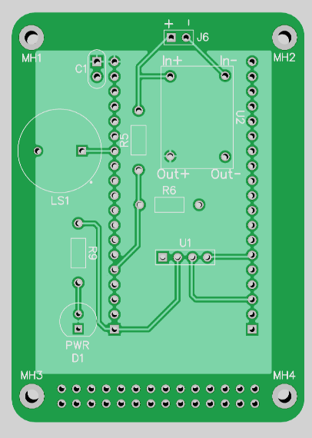

**Fig. 7.** PCB Layout of the Watch

The PCBs for both the Badge and the Watch are kept under 100x100mm for easy printing. The Badge sees the microcontroller on the top side as more room is available for the voltage regulator to sit above everything as the first input layer. The two LEDs are next to each other at the top so multiple cutouts for output are not required. The sensor is planned to sit outside of the PCB as the right angled headers point away. This room will be compensated. The Badge has a copper pour for the 5V on the top, and GND on the bottom. The Watch sees the microcontroller on the bottom as more room needs to be conserved for it to still be accessible as a watch. The watch sees the buzzer shifted away from the LED and the display is located at the center. The regulator is also shifted inward. The copper pours for this one are the same as the Badge, 5V on top, GND on bottom. The Badge has M3 holes, the Watch has M2 holes. Both have prototyping area at the bottom boards.

**3D Models**

**Fig. 8.** Bottom Badge Enclosure

**Fig. 9.** Top Badge Enclosure

The 3D models built for the Badge Enclosure are made a simple modular slide connector. The lip on the bottom part is made to fit any type of loop. Whether it’s a pin, magnetic clip, or anything else. As long as the loop fits in the opening it will connect. The top part was made with louvres in order to block out unwanted particulates while still collecting gas ppm. Within this version there is not a dedicated model for the Watch, the model shown in Fig. 1, simply exists as a stand in where the circle can be drilled out for the display.

**Coding**

The coding for this was done in Arduino [1]. The code was set up as a one-way communication protocol using the ESP’s internal Wi-Fi chip. The code used was based off of an existing two-way communication set up that was stripped down [2].

**Revisions**

Some revisions made from the original Badge board were the removal of multi-sensor loading.

**Fig. 10.** Schematic of the prior Badge

**Fig. 11.** PCB Layout of the prior Badge

The added sensors were used for redundancy, and a bulk capacitor was added for these sensors. However, as the prototype did not need the added usage of redundant parts, they were foregone for version 1. The bulk capacitor was forgone as well due to the lesser load. Most other components are the same. The size was larger than 100x100mm.

**Future Work**

The next steps planned for this are to include Energy Harvesting with the use of a Piezo Transducer. This will be surveyed and tested using the DC2151A Demoboard [3]. This will add to the feasibility of the wearable electronic. The resistor network used to read the voltage will also be changed so that voltage can properly be read. The sensor may be swapped out so that auto leveling may be included through software. The microcontroller may also be changed due to either size of capability. The watch will also get a dedicated model that may be based on a standard wearable watch breakout model or prototyping material to save design time. The badge will also get proper drill hole locations to match up with the future badge PCB.

**Fig. 12.** Image of Demoboard

**Bill Of Materials**

2x ESP32 - <https://www.amazon.com/HiLetgo-ESP-WROOM-32-Development-Microcontroller-Integrated/dp/B0718T232Z/>

2x 5V Regulator - <https://www.amazon.com/Regulator-Reducer-Converter-Aircraft-MP1584EN/dp/B0B779ZYN1/ref=sr_1_6?keywords=buck%2Bconverter%2B5v&qid=1699584282&sr=8-6&th=1>

1x Display - <https://www.amazon.com/UCTRONICS-SSD1306-Self-Luminous-Display-Raspberry/dp/B072Q2X2LL>

2x Battery of user choice (Link not required) - <https://www.amazon.com/EBL-Rechargeable-Batteries-Replacement-Electronics/dp/B087BYJ51T/ref=asc_df_B087BYJ51T/?tag=hyprod-20&linkCode=df0&hvadid=642102624616&hvpos=&hvnetw=g&hvrand=17707137417889697108&hvpone=&hvptwo=&hvqmt=&hvdev=c&hvdvcmdl=&hvlocint=&hvlocphy=9003792&hvtargid=pla-2143073881592&psc=1>

3x Generic Through Hole Diode

2x JST-XH

7x Resistor of choice

1x Piezo Buzzer

**References**

[1] Arduino, <https://www.arduino.cc/>

[2] ESP-NOW Two-Way Communication Between ESP32 Boards <https://randomnerdtutorials.com/esp-now-two-way-communication-esp32/>

[3] Analog Devices, "DC2151A: Evaluation Board for the ADP5054 Triple Buck Regulator," Analog Devices, Inc., Rev. 0, 2014. <https://www.analog.com/media/en/technical-documentation/user-guides/DC2151AF.PDF>